Project INFINITE: Slovenian partners' activities so far
In the first eight months of the project (i.e. in the first phase) the following activities took place:
- A working group for the Slovenian demonstration building was formed:
  - the concept of the project was presented to the stakeholders.

- Initial activities at Slovenian demo case building:
- preparation of an extended energy audit,
- a 3D scan of the building to create a BIM model,
- a geometry audit of the building with detailed field inspections,
- a structural analysis of the building,
- creation of the monitoring concept,
- investigation of the Slovenian legislation regarding renovation.

- Implementation of stakeholder-centred approach:
- focus groups with final users (building manager, janitor, residents) at Slovenian demo building,
- workshops with project partners on acceptance of INFINITE technologies,
- focus groups with representatives of nationally relevant institutions on acceptance of INFINITE technologies,
- short ethnography inspired research (interviews, observation, informal conversations, participant observation) at Slovenian demo building,
- transference of the stakeholder-centred research to the Italian and French demonstration buildings,
- draft reports on requirements for the development of 1) Building Management System (BMS) and 2) BIM based platform, written as the result of the described activities.

Photos with description

- Photos show the process of geometry audit of the building prior to the renovation. July 2021. Photo: Jure Jevšenak

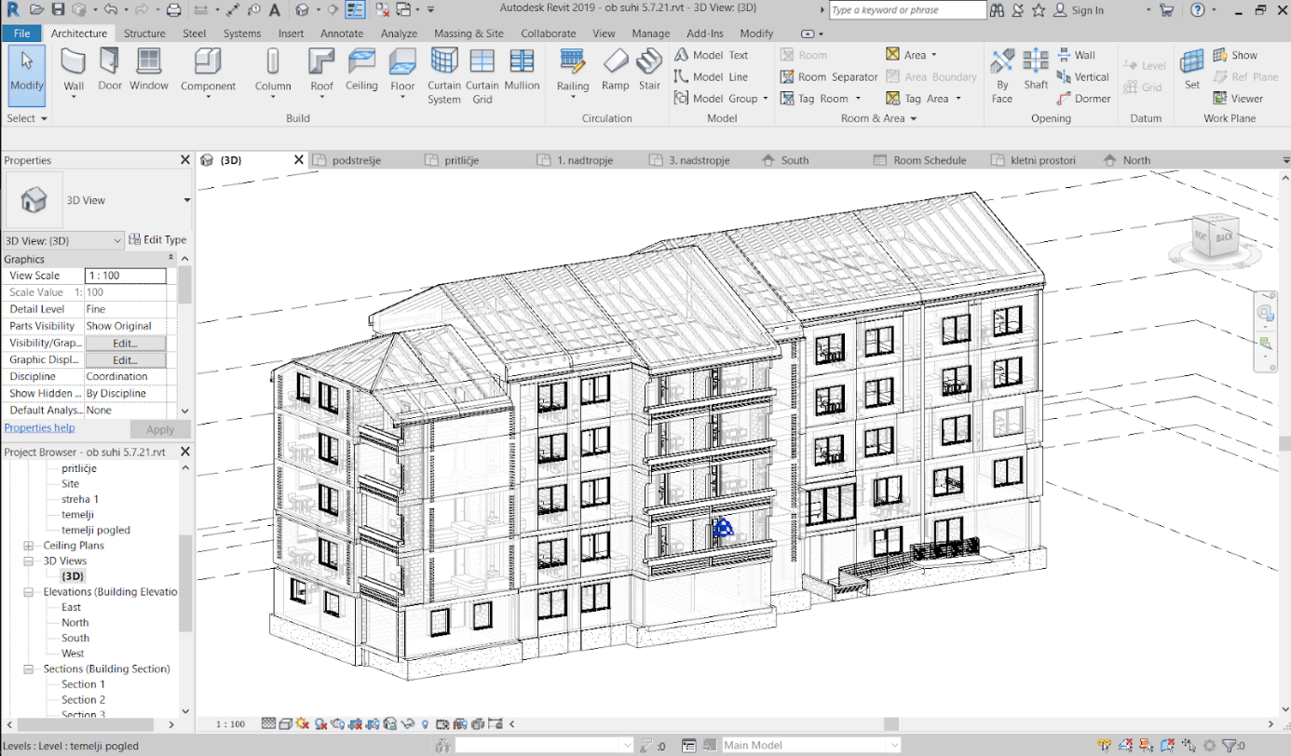

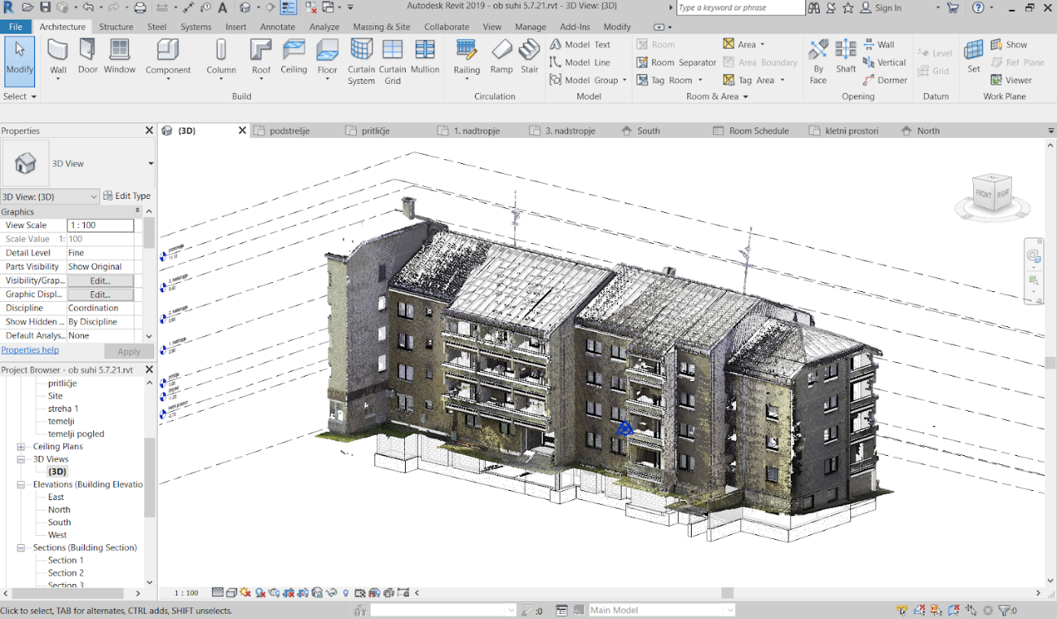

- (Post)epidemic project activity conducted outdoors: Focus group with end-users in the Slovenian demonstration building. Ravne na Koroškem, March 2021. Photo: Jure Vetršek.

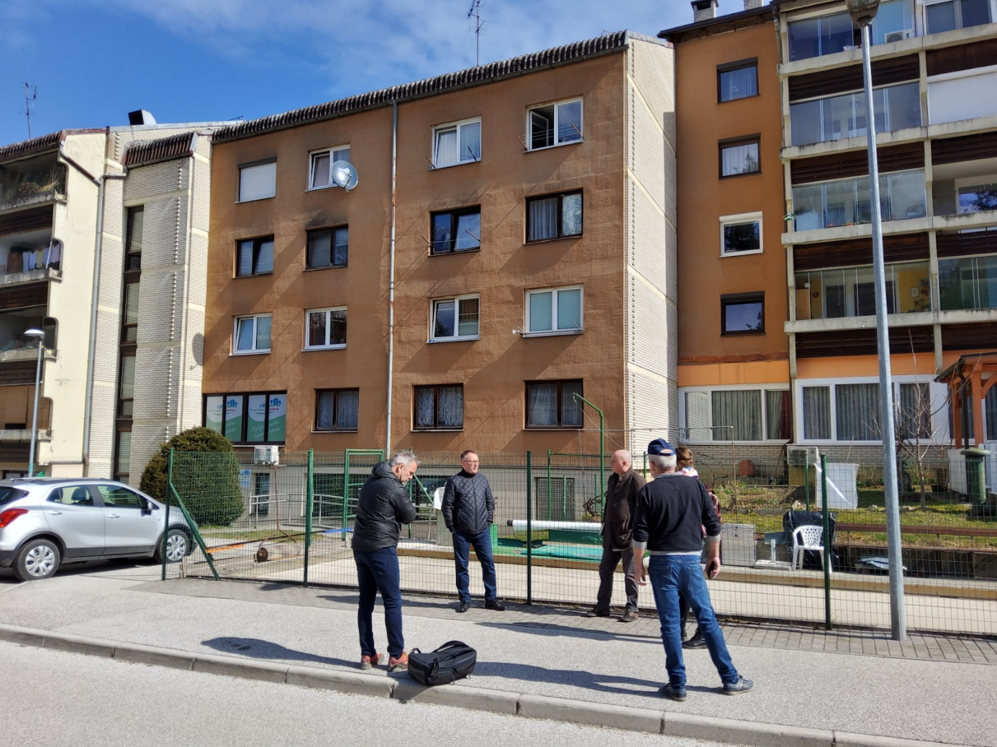

- (Post)epidemic project activity conducted indoors: Focus group with designers, architects and engineers. Ljubljana, June 2021. Photo: Jure Vetršek

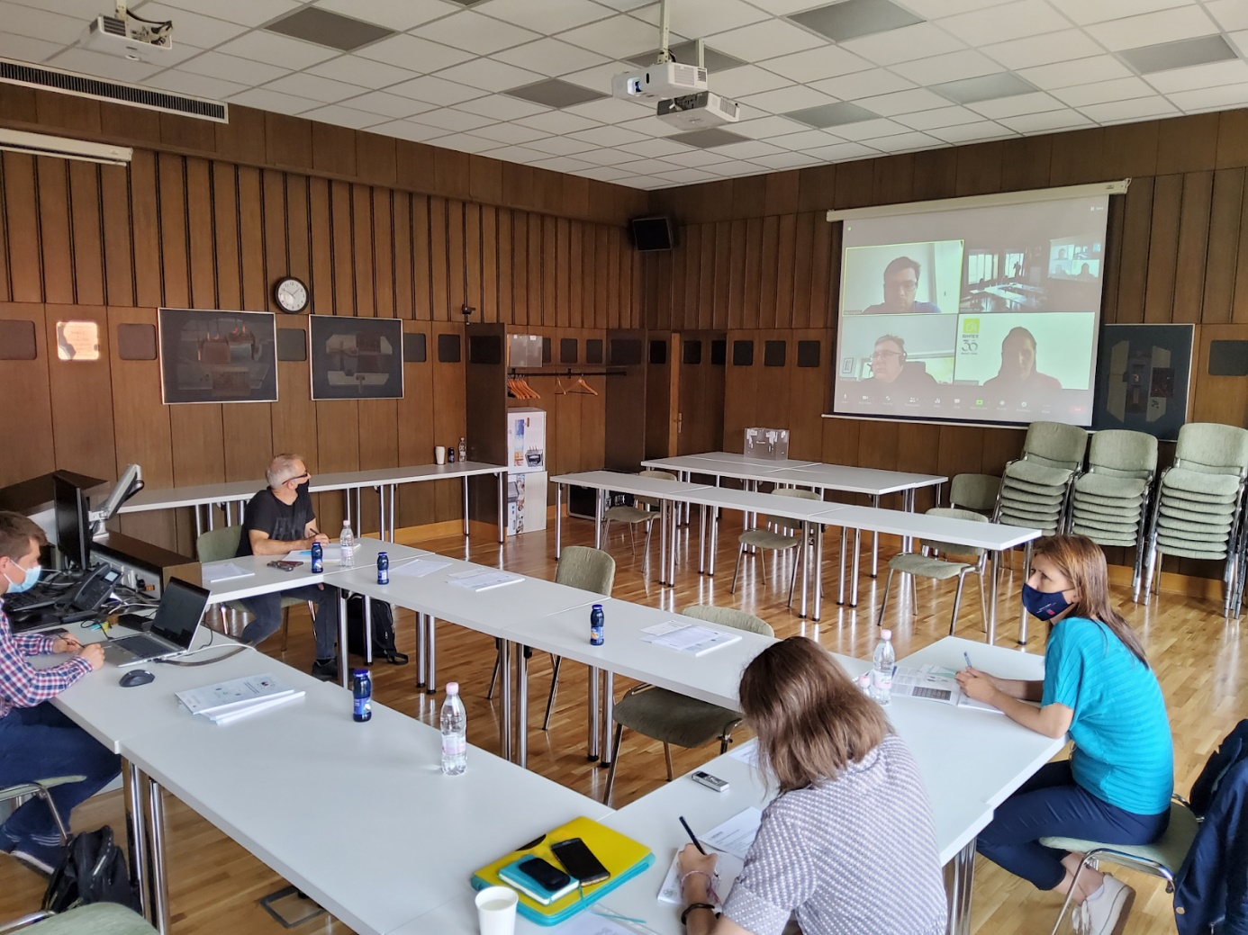

- Impressions from ethnographic inspired research work at Slovenian demonstration building. Ravne na Koroškem, July 2021. Photo: Veronika Zavratnik.
